Creating Uptime checks

Step 1: Click on "Create Uptime Check" and select the HTTPS protocol and URL Resource type.

Step 2: Enter the hostname (the domain name of your application).

Step 3: Enter the context path of your application (e.g., /pact/).

Step 4: Click on "More Target Options" and select the specific regions you want for notifications (select the US region locations).

Step 5: Click on the notification channel and add the list of members who should receive the alerts.

Step 6: Provide a name for the uptime check according to the name of the application.  
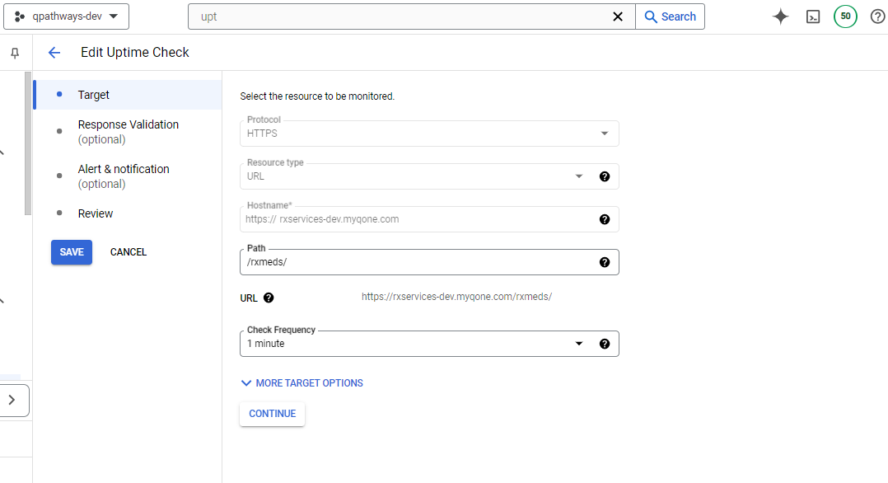  
  
If you want to add the another member in to the existing uptime check notification channel.

Search the policies on the search bar and then filter the policy nam  
  
  
  
  
Edit the policy and go to notification s  
  
